Attention Music Students Grades 5 – 12!
Learn to be your very best…play like you’ve never played before!
2017 Judith Lapple Summer Woodwind Camp!
Monday, July 17 – Saturday, July 22
Trinity Christian School in Fairfax, VA
(just minutes from George Mason University!)

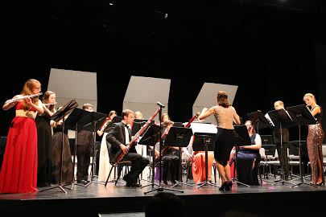
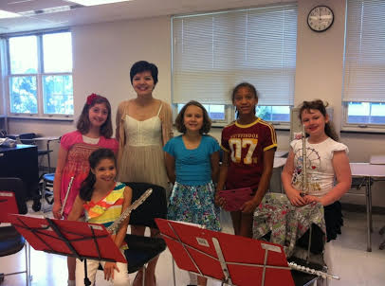
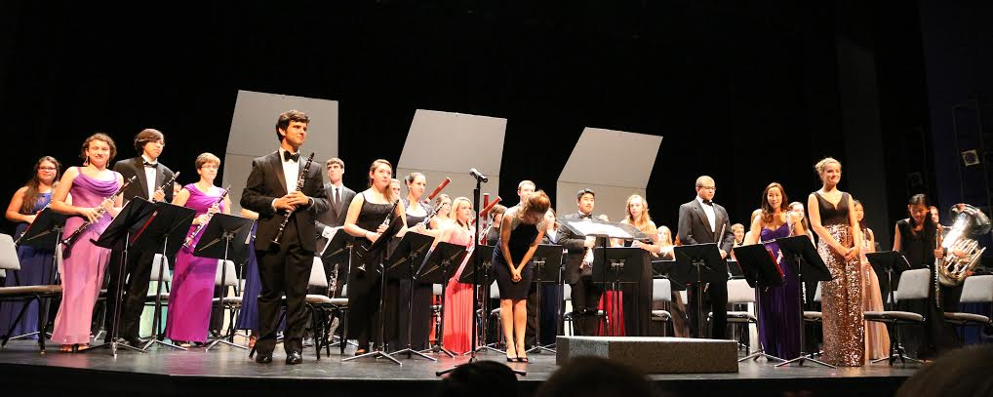
The camp welcomes flute, oboe, clarinet, bassoon, saxophone, and French horn. Daily activities include ensemble playing, chamber music, private lessons, master classes and workshops on musicianship and performing!

For more information visit:
WWW.JLWOODWINDCAMP.COM
Or contact the director, Jennifer Lapple, at jlapple917@gmail.com

